**MySQL Exercise 2**

1.

CREATE TABLE numbers (

value INT

);

INSERT INTO numbers (value)

VALUES (5), (12), (8), (20), (3);

SELECT value

FROM numbers

WHERE value BETWEEN 5 AND 15;

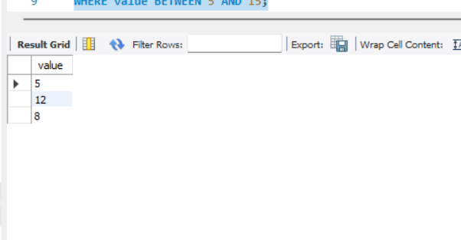

2.

CREATE TABLE triangles (

side1 INT,

side2 INT,

side3 INT

);

INSERT INTO triangles (side1, side2, side3)

VALUES (3, 4, 5),

(2, 2, 5),

(5, 7, 4);

SELECT side1, side2, side3,

CASE

WHEN side1 + side2 > side3 AND side1 + side3 > side2 AND side2 + side3 > side1 THEN 'Valid Triangle'

ELSE 'Invalid Triangle'

END AS triangle_type

FROM triangles;

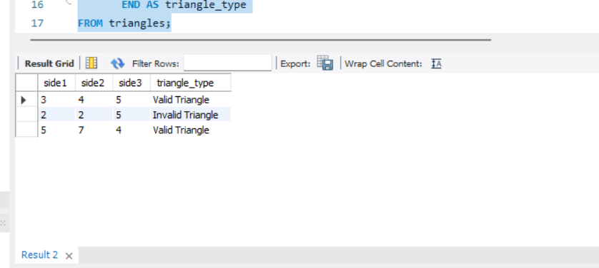

3.

CREATE TABLE years (

year INT

);

INSERT INTO years (year)

VALUES (2020), (2021), (1900), (2000);

SELECT year,

CASE

WHEN (year MOD 4 = 0 AND year MOD 100 != 0) OR (year MOD 400 = 0) THEN 'Leap Year'

ELSE 'Not a Leap Year'

END AS leap_year_status

FROM years;

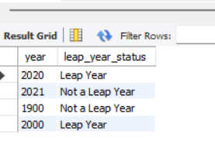

4.

CREATE TABLE strings (

string1 VARCHAR(100),

string2 VARCHAR(100)

);

INSERT INTO strings (string1, string2)

VALUES ('hello world', 'world'),

('programming', 'gram'),

('database', 'house');

SELECT string1, string2,

CASE

WHEN LOCATE(string2, string1) > 0 THEN 'string2 is in string1'

ELSE 'string2 is not in string1'

END AS containment_status

FROM strings;

